Table of Contents

**1. Recruitment Flow** 2

**2. Test Question Flow** 5

**3. Test Template Flow** 6

**4. New Candidate Flow** 8

# **1. Recruitment Flow: Vacany**

1. Go to URL: <https://beta.mipeople.co/login/user_login>
2. Click Side Menu button to open the Side Menu.
3. Click on the second side menu item i.e. Recruitment to open its sub menu.
4. Click Vacancy.
5. Click Add.
6. Fill in all the fields for Vacancy and click Next button located at the end of the form.

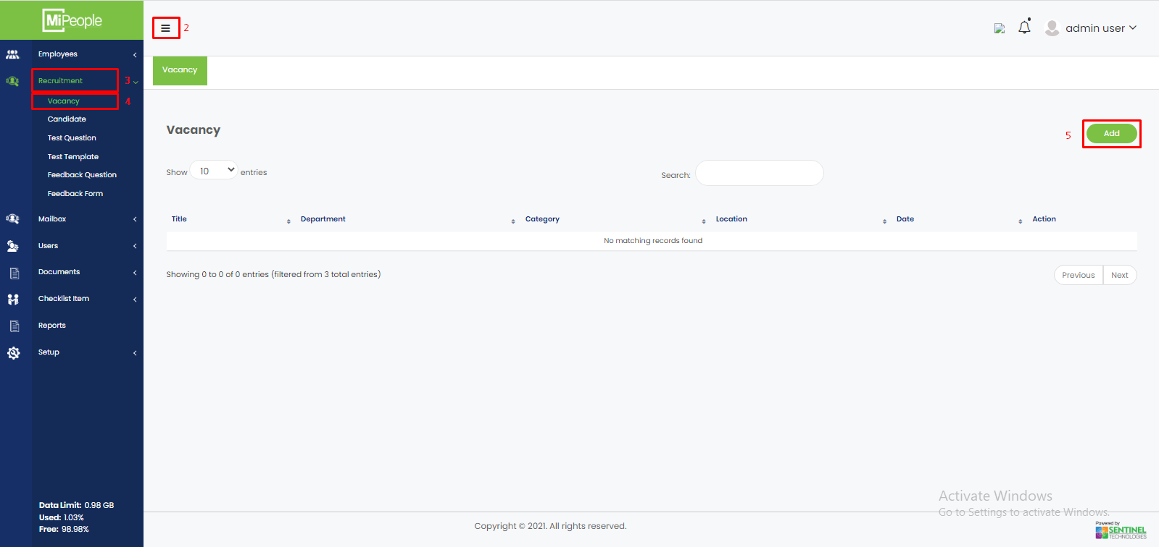

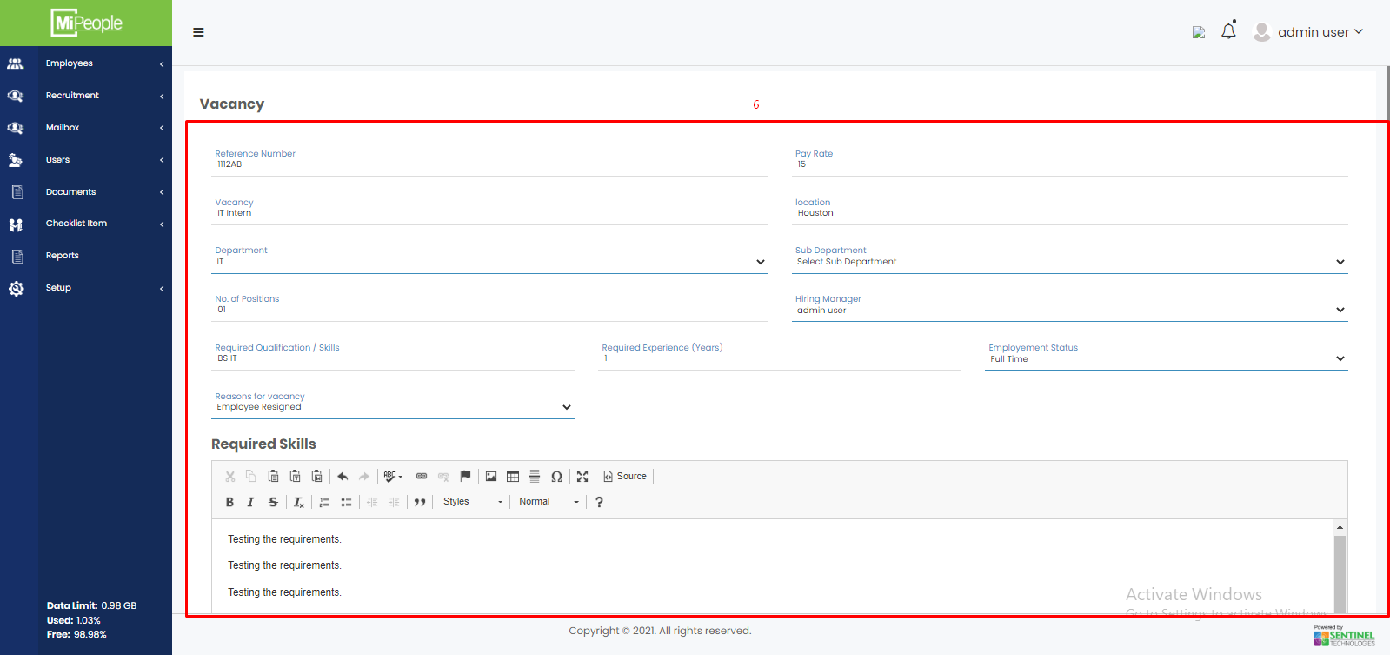

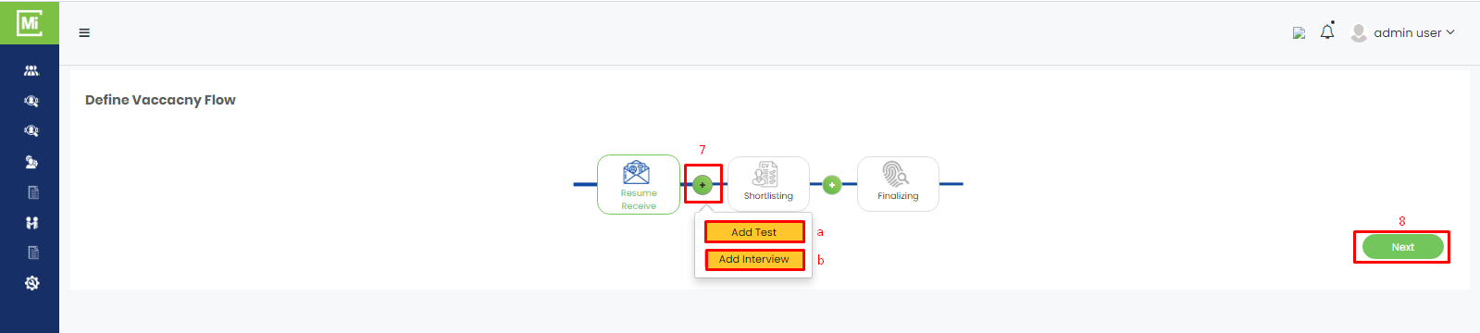

1. Click + button to add in the Vacancy Flow;
   1. Test
   2. Interview
2. Click Next.
3. Open the drop down and Select a User who will receive the Resumes.
4. Click Save and Exit.

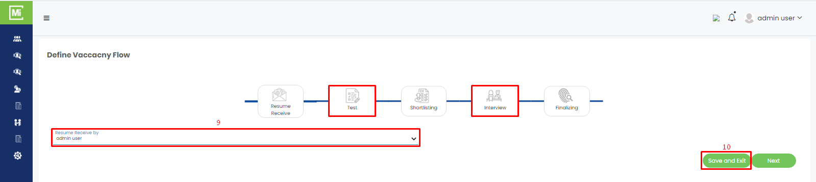

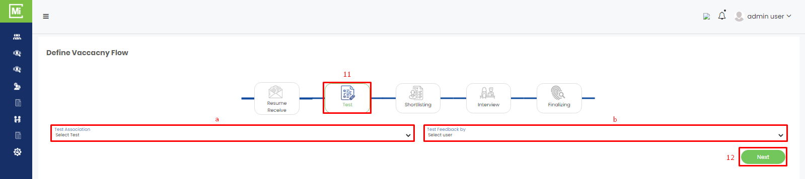

1. Now to define the test;
   1. Select test association from the drop down.
   2. Select the user from the drop down who will give the test feedback.
2. Click Next.
3. Select the person who will shortlist the resumes.
4. Click Next button.
5. Fill in the form for Interview section.
6. Click Next button.

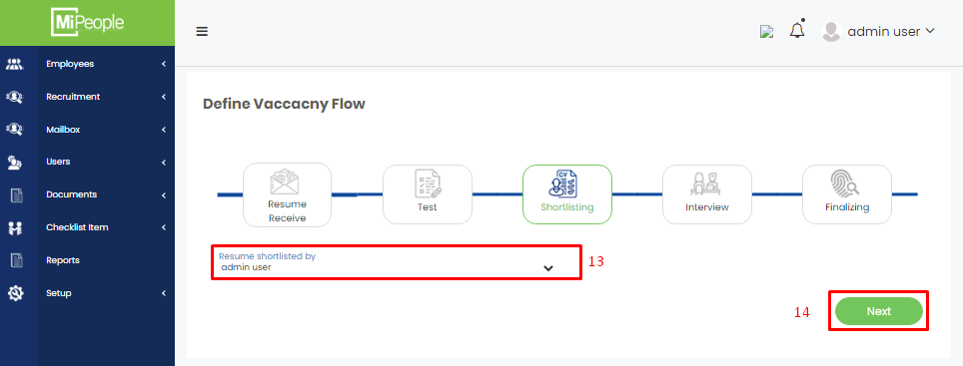

1. Now select the person who will finalize the interview.
2. Click Next.
3. Here your completed vacancy in the table.

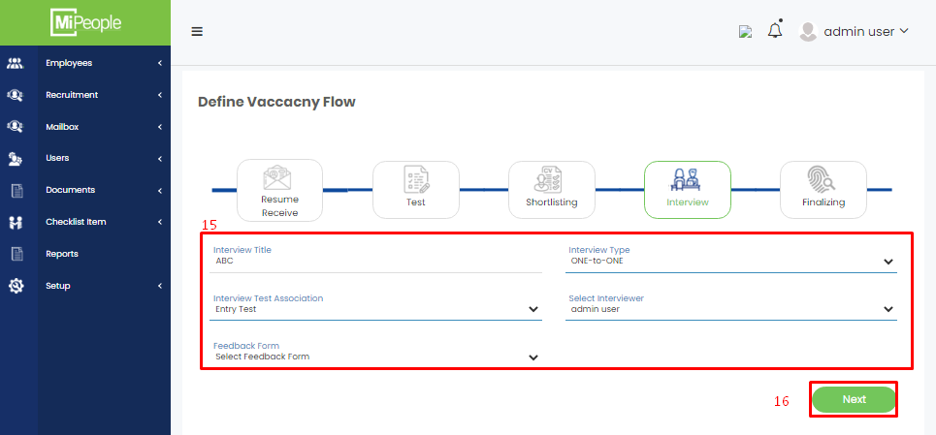

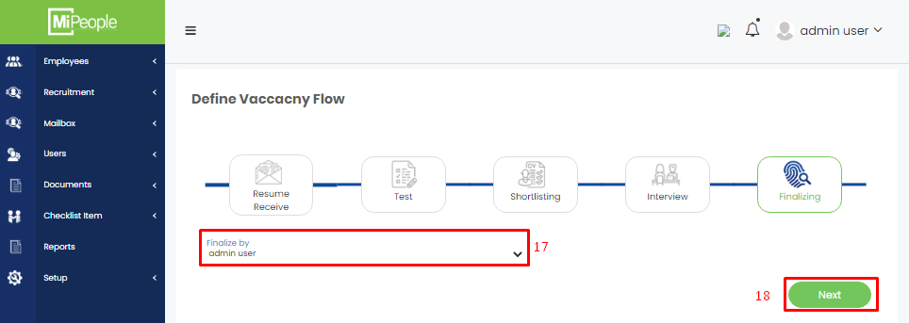

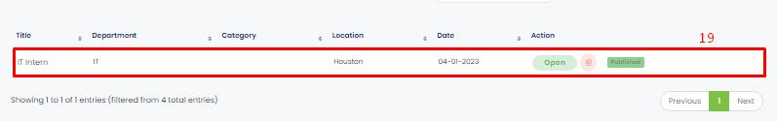

# **2. Recruitment Flow: Test Question**

1. Go to URL: <https://beta.mipeople.co/login/user_login>
2. Click Side Menu button.
3. Click Recruitment in the Side Menu to open its sub menu.
4. Click Test Question in the sub menu.

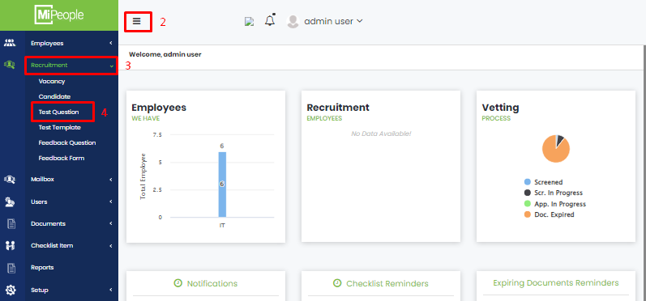

1. Click Add
2. Fill in the fields required to add a new test question.
3. Click Save.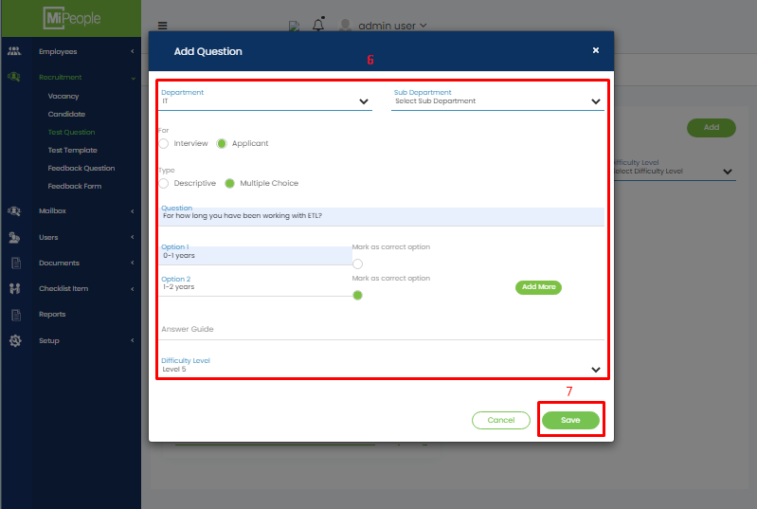

# **3. Recruitment Flow: Test Template**

1. Go to URL: <https://beta.mipeople.co/login/user_login>
2. Click Side Menu button.
3. Click Recruitment in the Side Menu to open its sub menu.
4. Click Test Template.
5. Click Add button.

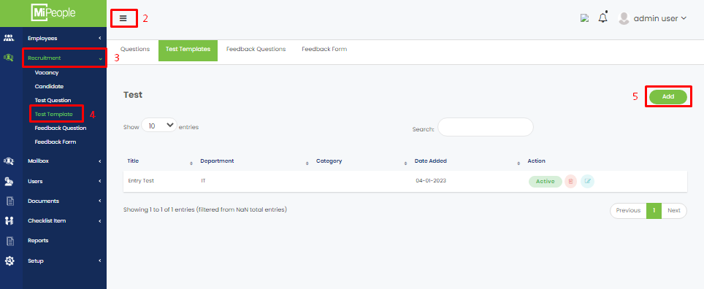

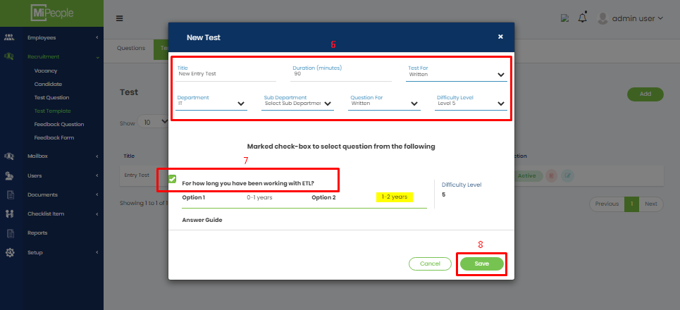

1. Fill in all required fields to create new test template.
2. Check Questions you have created earlier that you want to include in this test.
3. Click Save Button.

# **4. Recruitment Flow: New Candidate**

1. Go to URL: <https://beta.mipeople.co/login/user_login>
2. Click Side Menu button.
3. Click Recruitment in the Side Menu to open sub menu.
4. Click Candidate in the sub menu.
5. Click Add button.

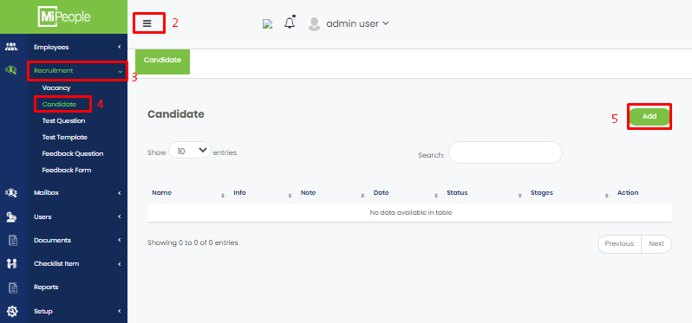

1. Fill in all the fields that are required in adding a new candidate.
2. Click Save.

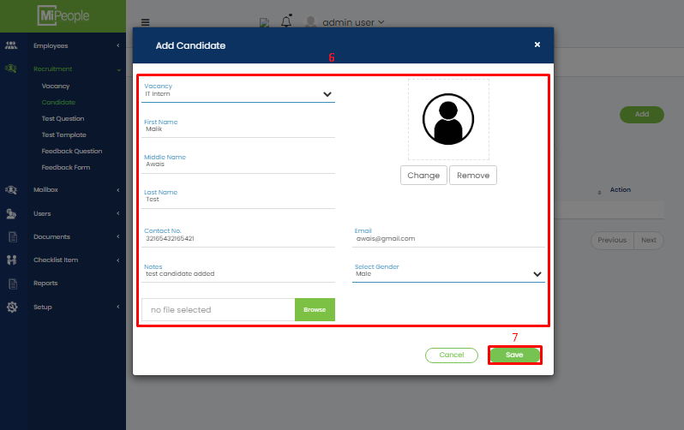

# **5. Recruitment Flow: Accept Resume from Each Candidate**

1. Go to URL: <https://beta.mipeople.co/login/user_login>
2. Click Side Menu button.
3. Click Recruitment in the Side Menu to open sub menu.
4. Click Candidate in the sub menu.
5. Click on the drop down menu of column Stages and select the option Accept Resume.
6. Click Yes for confirmation.

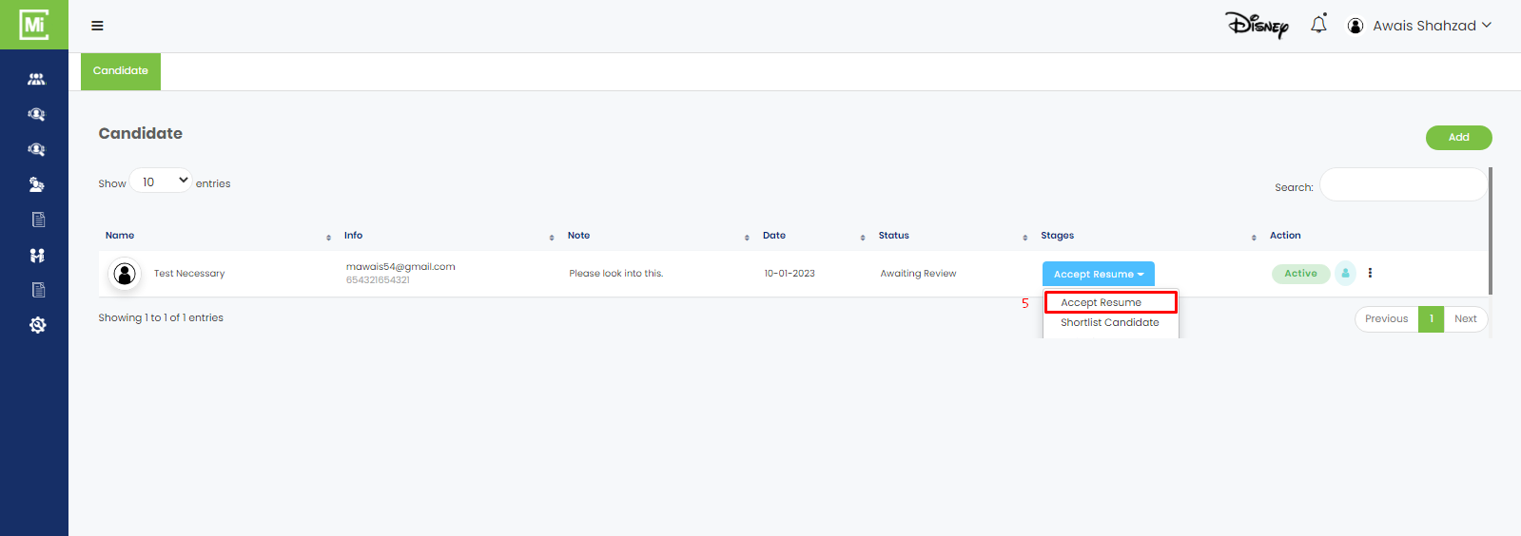

# **6. Recruitment Flow: Shortlist Candidate**

1. Go to URL: <https://beta.mipeople.co/login/user_login>
2. Click Side Menu button.
3. Click Recruitment in the Side Menu to open sub menu.
4. Click Candidate in the sub menu.
5. Click on the drop down menu of column Stages and select the option Shortlist Candidate.
6. Click Yes for confirmation.

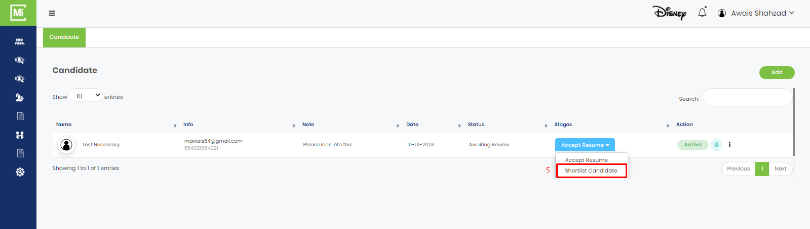

# **7. Recruitment Flow: Email Test to Candidate**

1. Go to URL: <https://beta.mipeople.co/login/user_login>
2. Click Side Menu button.
3. Click Recruitment in the Side Menu to open sub menu.
4. Click Candidate in the sub menu.
5. Click on the drop down menu of column Stages and select the option Invite for Test.
6. A form will open. Fill in all the required fields.
7. Click Save.
8. An email will be sent on defined email where candidate needs to start the test.

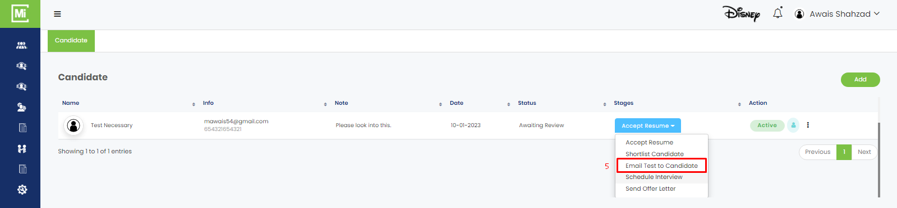

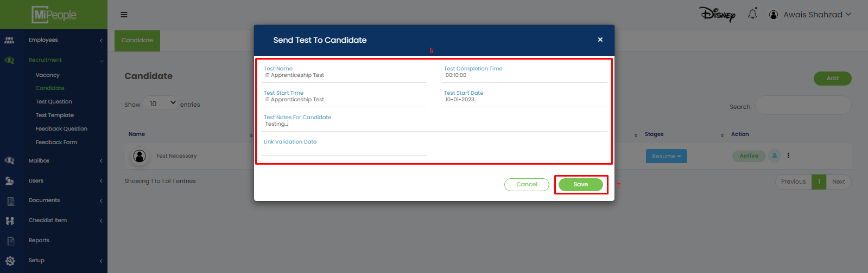

# **8. Recruitment Flow: Schedule Interview**

1. Go to URL: <https://beta.mipeople.co/login/user_login>
2. Click Side Menu button.
3. Click Recruitment in the Side Menu to open sub menu.
4. Click Candidate in the sub menu.
5. Click on the drop down menu of column Stages and select the option Schedule Interview.
6. A form will open. Fill in all the required fields.
7. Click Schedule.

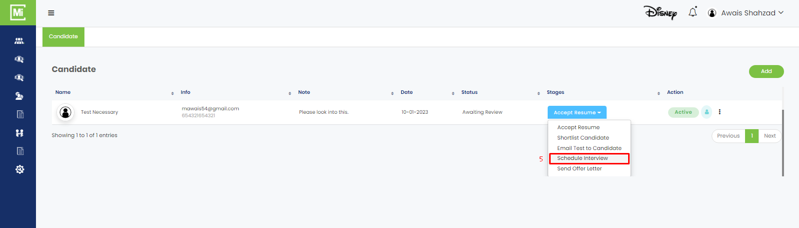

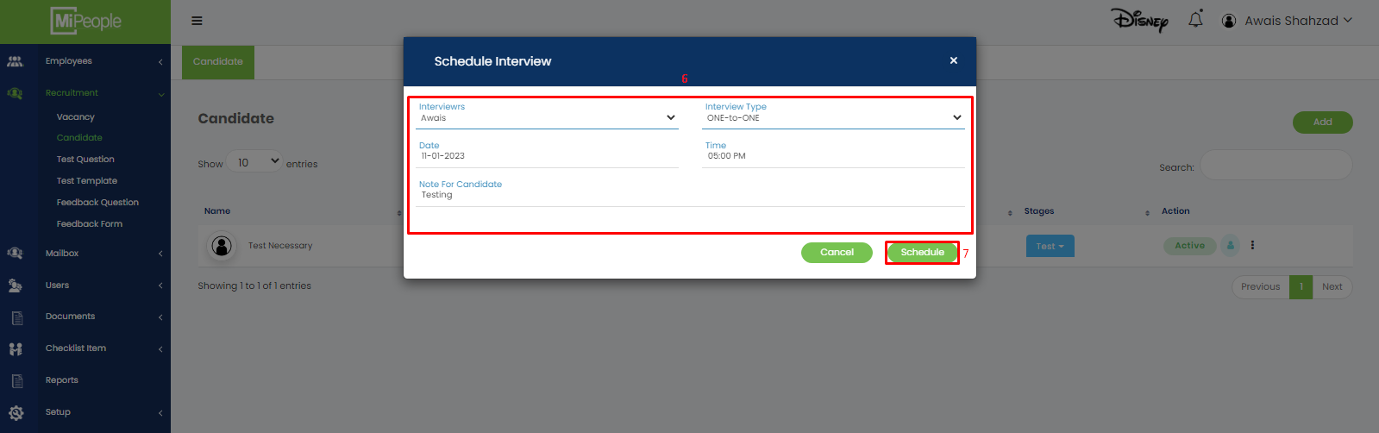

# **9. Recruitment Flow: Send Offer Letter**

1. Go to URL: <https://beta.mipeople.co/login/user_login>
2. Click Side Menu button.
3. Click Recruitment in the Side Menu to open sub menu.
4. Click Candidate in the sub menu.
5. Click on the drop down menu of column Stages and select the option Send Offer Letter.
6. A form will open. Fill in all the required fields.
7. Click Send.

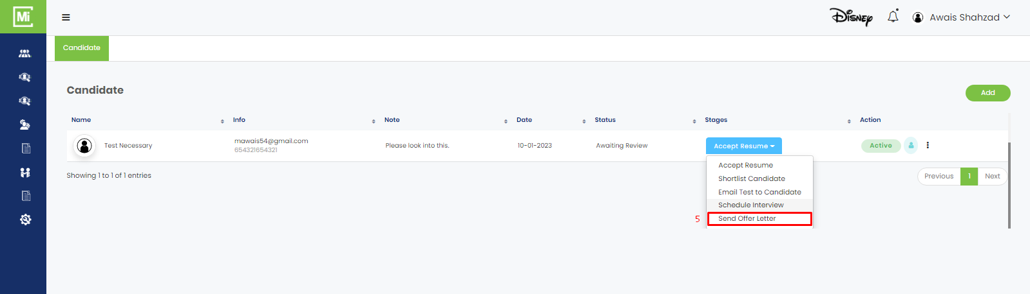

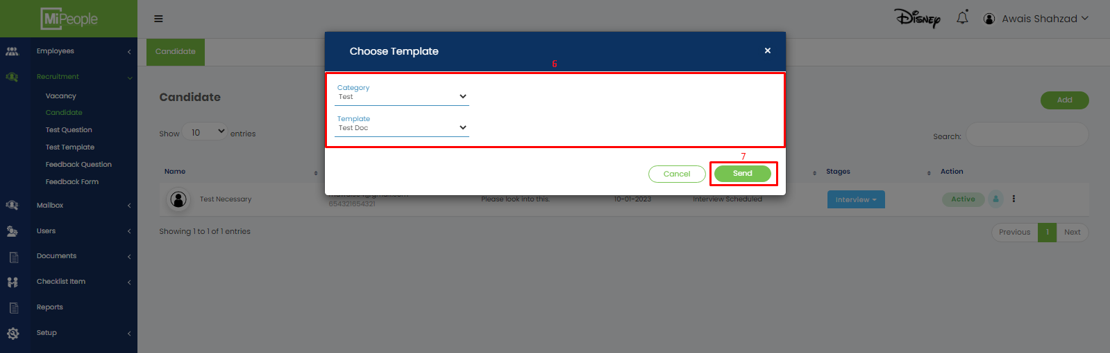

# **10. Recruitment Flow: Feedback Question**

1. Go to URL: <https://beta.mipeople.co/login/user_login>
2. Click Side Menu button.
3. Click Recruitment in the Side Menu to open sub menu.
4. Click Feedback Question in the sub menu.
5. Click Add New.
6. Add Question form will open. Fill in all the required fields.
7. Click Save.

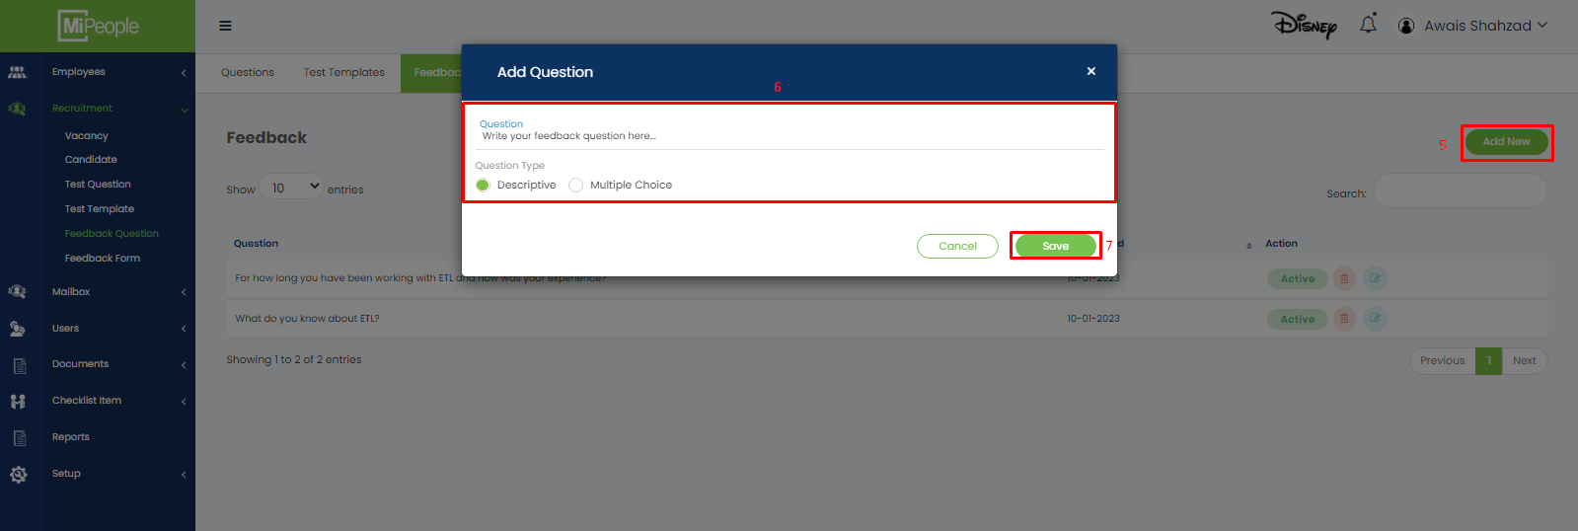

# **11. Recruitment Flow: Feedback Form**

1. Go to URL: <https://beta.mipeople.co/login/user_login>
2. Click Side Menu button.
3. Click Recruitment in the Side Menu to open sub menu.
4. Click Feedback Form in the sub menu.
5. Click Add New.
6. Add Question form will open. Fill in all the required fields.
7. Click Save.

